Name: Dhairya Marwah

University Roll No. 2016278

Roll No. 42

Sec. B

**PROGRAM 1**

#include <math.h>

#include <stdio.h>

int main() {

double a, b, c, discriminant, r1, r2, realPart, imagPart;

printf("Sugandhi Arora, 2017074, Roll No. 12, Sec. B\n");

printf("Enter coefficients a,b,c: ");

scanf("%lf%lf%lf",&a,&b,&c);

discriminant=b*b-4*a*c;

//real and different roots

if (discriminant>0)

{

r1=(-b+sqrt(discriminant))/(2*a);

r2=(-b-sqrt(discriminant))/(2*a);

printf("Roots are real and distinct\n");

printf("r1= %.2lf and r2=%.2lf", r1, r2);

}

//real and equal roots

else if (discriminant==0)

{

r1=r2=-b/(2*a);

printf("Roots are real and equal\n");

printf("r1=r2=%.2lf", r1);

}

//roots are imaginary

else

{

realPart=-b/(2*a);

imagPart=sqrt(-discriminant)/(2*a);

printf("Roots are imaginary\n");

printf("r1=%.2lf+%.2lfi and r2=%.2f-%.2fi", realPart, imagPart, realPart, imagPart);

}

return 0;

}



Name: Dhairya Marwah

Sec. B

Roll No. 42

University Roll No. 2016728

**Practical 2**

Q2) WAP in C to find the roots of the equation using the bisection method.

#include <math.h>

#include <stdio.h>

double f(double x)

{

return 3*x + sin(x) - exp(x) ;

}

int main()

{

printf("Name: Sugandhi Arora\nSem: 5\nSec/Roll: B-12\nUniversity Roll: 2017074\n\n");

double c = 0, x0, x1;

int i=1;

// calculating tolerance

int noDigits = 4;

double t = 0.5 * pow(10.0, -noDigits);

x0 = 0;

x1 = 0;

printf("Function : 3x + sin(x) - exp(x) \n");

while (f(x0) * f(x1) > 0 || x0 == x1)

{

printf("Enter a valid range:: ");

scanf("%lf %lf", &x0, &x1);

}

double x_prev = 0;

printf("Iteration| x0\t | c\t\t | x1\t | f(c)\n\n");

while (1)

{

x_prev = c;

c = (x0 + x1) / 2;

printf(" %d\t | %lf\t | %lf\t | %lf\t | %lf\n",i, x0, c, x1, f(c));

i++;

if (f(c) == 0)

{

printf("\nResult is :: %lf", c);

break;

}

else if (f(x0) * f(c) < 0)

{

x1 = c;

}

else

{

x0 = c;

}

if (fabs(c - x_prev) <= t)

{

printf("\n\nResult is :: %lf within %lf tolerance\n\n", c, t);

break;

}

}

return 0;

}

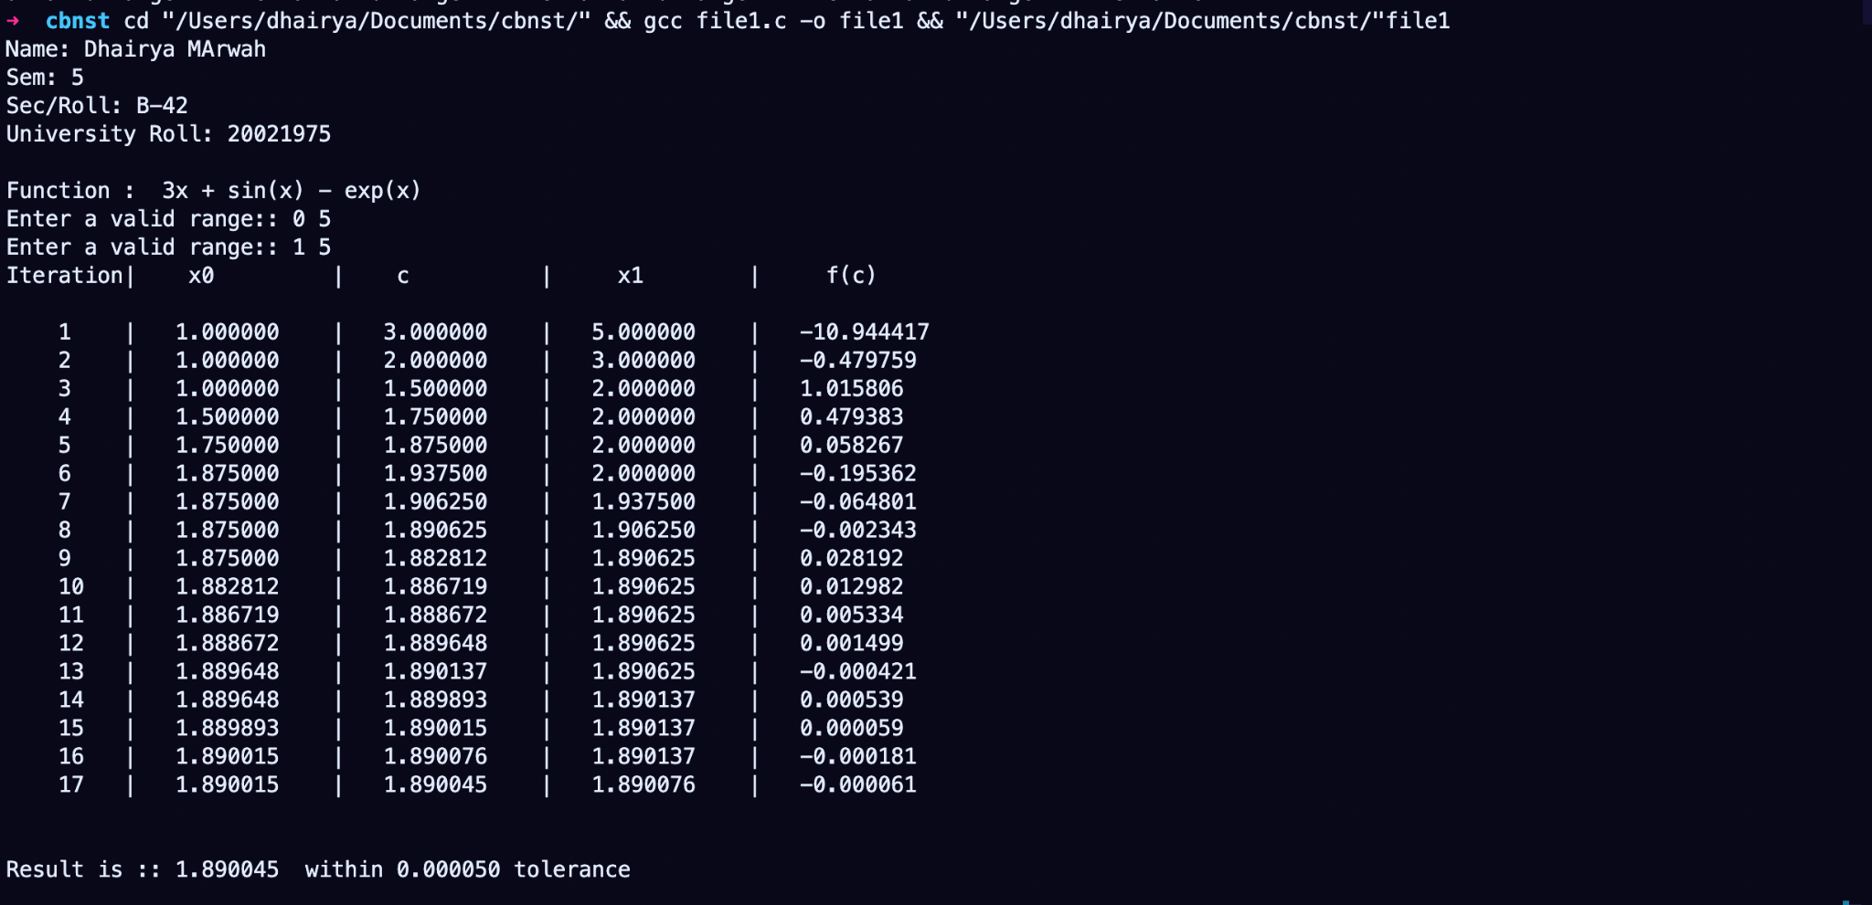

Name: Dhairya Marwah

Sec. B

Roll No. 42

University Roll No. 2016728

**Practical 3**

Q3) WAP in C to find the root of equation using Regula Falsi Method.

#include <stdio.h>

#include <math.h>

double f(double x)

{

return 3*x + sin(x) - exp(x);

}

int main()

{

double c = 0, x0, x1;

printf("Name: Sugandhi Arora\nSem: 5\nSec/Roll: B-12\nUniversity Roll: 2017074\n\n");

printf("Function : 3x + sin(x) - exp(x) \n");

int noDigits = 4;

double t = 0.5 * pow(10.0, -noDigits);

x0 = 0;

x1 = 0;

int i=1;

while (f(x0) * f(x1) > 0 || x0 == x1)

{

printf("Enter a valid range:: ");

scanf("%lf %lf", &x0, &x1);

}

double x_prev = 0;

printf("Iteration| x0\t | c\t\t | x1\t | f(c)\n\n");

while (1)

{

x_prev = c;

c = (x0 * f(x1) - x1 * f(x0)) / (f(x1) - f(x0));

printf(" %d\t | %lf\t | %lf\t | %lf\t | %lf\n",i, x0, c, x1, f(c));

i++;

if (f(c) == 0)

{

printf("\nResult is :: %lf", c);

break;

}

else if (f(x0) * f(c) < 0)

{

x1 = c;

}

else

{

x0 = c;

}

if (fabs(c - x_prev) < t)

{

printf("\n\nResult is :: %lf within %lf tolerance\n\n", c, t);

break;

}

}

return 0;

}

